Assignments on Generics

1)Use a HashSet to hold Employee objects. upon running the application, the details of the employees added to the HashSet should be displayed.

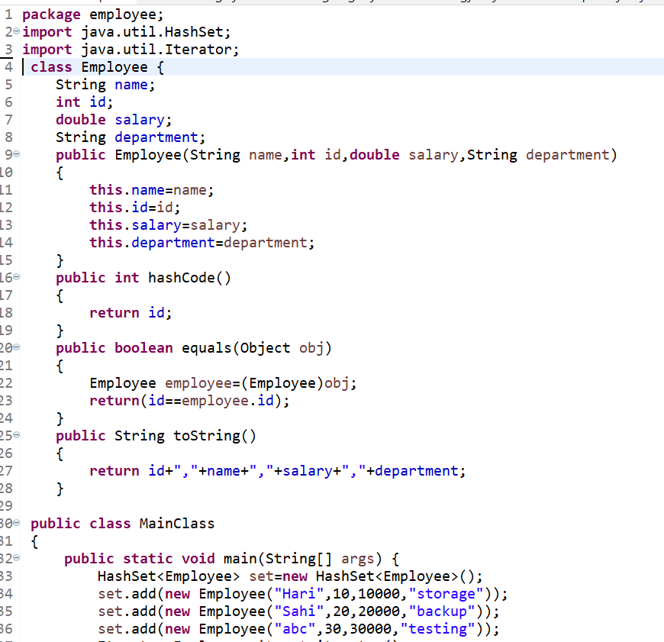

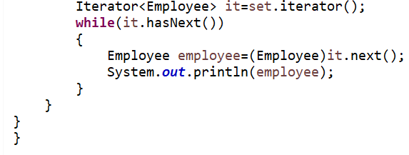

Output:

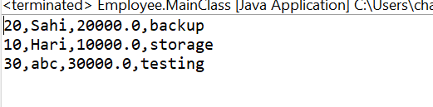

2)Write an application to hold 10 random values int values as keys and 10 random double values as values for a hash map. print the data store in the hash map.

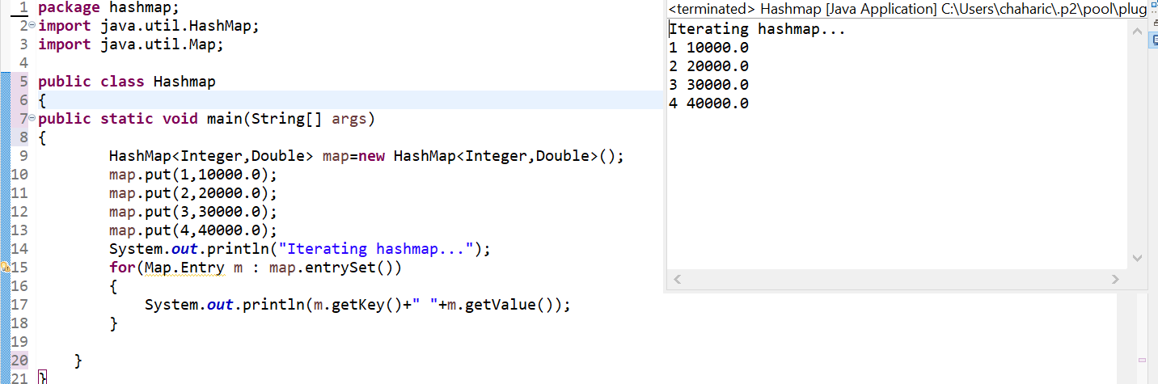

3)Write a generic method to exchange the positions of two different elements in an array.

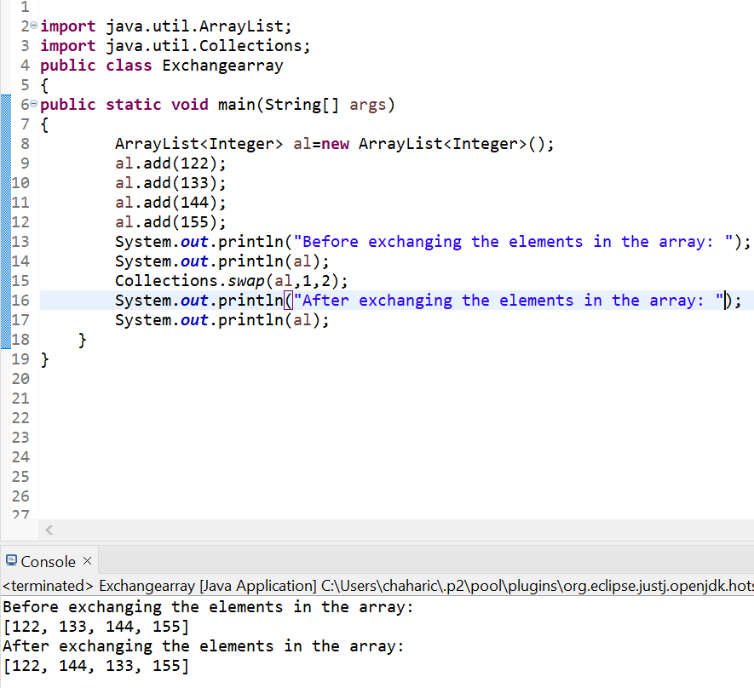

4)Design a class named pairs which has two properties. This name of the first property is key and that of the second property is value. When designing the class take care of the following scenarios.

A) Create an object of pair class to store String value for the property key and string value for the property value.

B) Create an object of the class pairs to store String values for the property key and java.util. Date as value for the property value.

